Unit 1 My Dream Job

A
2. I like this job because I like to help sick people.
3. I like this job because I like to grow flowers.
4. I like this job because I love to draw cartoons.

B
2. I will cure many patients when I am a doctor.
3. I will make beautiful flower bouquets when I am a florist.
4. I will work on animated films when I am an animator.

C
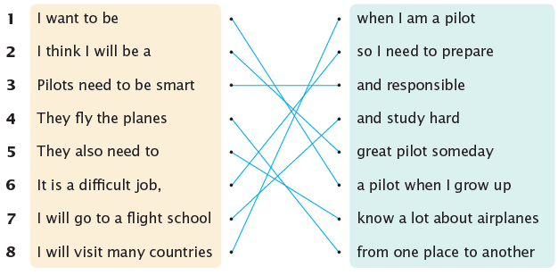
1. I want to be a pilot when I grow up.
2. I think I will be a great pilot someday!
3. Pilots need to be smart and responsible.
4. They fly the planes from one place to another.
5. They also need to know a lot about airplanes.
6. It is a difficult job, so I need to prepare.
7. I will go to a flight school and study hard.
8. I will visit many countries when I am a pilot.

Unit 2 My Weekend

A
2. I sometimes make pancakes.
3. I always get up early.
4. I often make fresh juice

B
2. After lunch, I go to the library.
3. After lunch, I watch music videos on YouTube.
4. After dinner, I go for a walk.

C
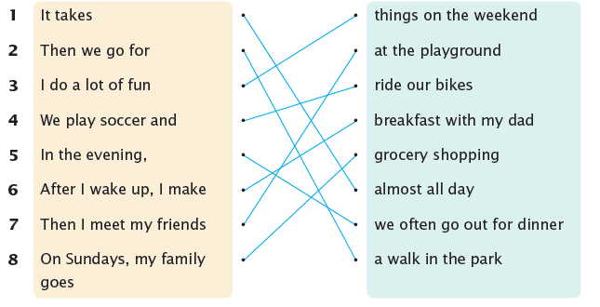

1. It takes almost all day.
2. Then we go for a walk in the park.
3. I do a lot of fun things on the weekend.
4. We play soccer and ride our bikes.
5. In the evening, we often go out for dinner.
6. After I wake up, I make breakfast with my dad.
7. Then I meet my friends at the playground.
8. On Sundays, my family goes grocery shopping.

Unit 3 My Special Birthday Gift

A
2. I thought it was so pretty.
3. It was inside a blue bag.
4. I opened the bag and saw a new diary.

B
2. Last year, my aunt gave me a special gift.
3. Two years ago, my grandmother gave me a special gift.
4. Last year, my parents gave me a special gift

C
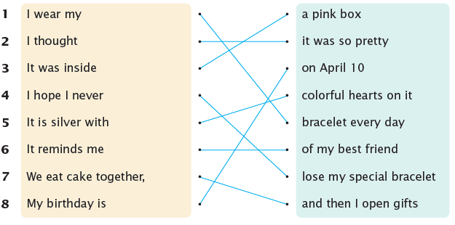

1. I wear my bracelet every day.
2. I thought it was so pretty!
3. It was inside a pink box.
4. I hope I never lose my special bracelet.
5. It is silver with colorful hearts on it.
6. It reminds me of my best friend.
7. We eat cake together, and then I open gifts.
8. My birthday is on April 10.

Unit 4 My Favorite Teacher

A
2. She made English interesting.
3. He made P.E. exciting.
4. He made social studies enjoyable.

B
2. P.E. is more exciting than other subjects.
3. Social studies is more important than other subjects.
4. Science is better than other subjects.

C
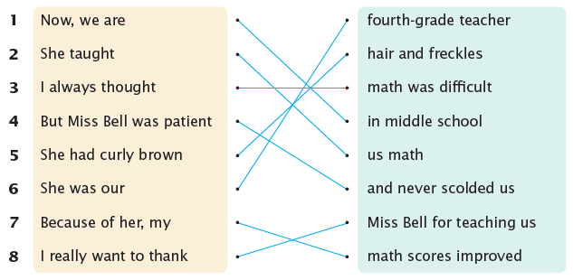

1. Now, we are in middle school.
2. She taught us math.
3. I always thought math was difficult.
4. But Miss Bell was patient and never scolded us.
5. She had curly brown hair and freckles.
6. She was our fourth-grade teacher.
7. Because of her, my math scores improved.
8. I really want to thank Miss Bell for teaching us.

Unit 5 Follow the Rules

A
2. You should clean up when the movie is over.
3. You should not make noise in the restaurant.
4. You should pet the animals gently.

B
2. Before you go into the movie theater, lower your voice.
3. Before you go into the swimming pool, warm up.
4. Before you go into the school, slow down and be quiet.

C
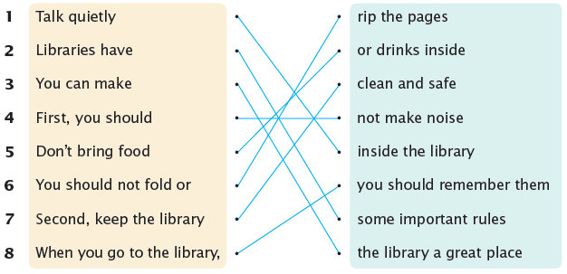

1. Talk quietly inside the library.
2. Libraries have some important rules.
3. You can make the library a great place.
4. First, you should not make noise.
5. Don’t bring food or drinks inside.
6. You should not fold or rip the pages.
7. Second, keep the library clean and safe.
8. When you go to the library, you should remember them.

Unit 6 A Famous Food

A
2. It looks colorful and tastes delicious.
3. They smell delicious and taste sweet.
4. They smell salty but taste amazing.

B
2. If you visit Sweden, you should order some cinnamon rolls.
3. If you visit Mexico, you should order some tacos.
4. If you visit Japan, you should order some mochi.

C
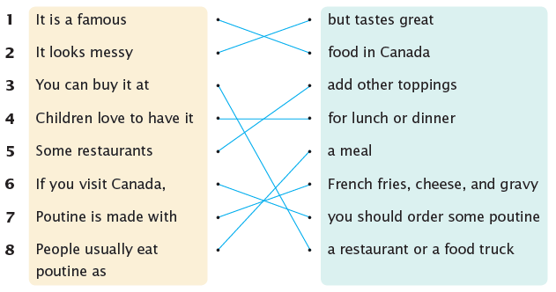

1. It is a famous food in Canada.
2. It looks messy but tastes great.
3. You can buy it at a restaurant or a food truck.
4. Children love to have it for lunch or dinner.
5. Some restaurants add other toppings.
6. If you visit Canada, you should order some poutine!
7. Poutine is made with French fries, cheese, and gravy.
8. People usually eat poutine as a meal.
Unit 7 The Best Place in My Town

A
2. There are many foods to eat.
3. There are many snacks to eat.
4. There are a lot of activities to do.

B
2. Why don’t you visit the Smith Art Gallery with your friends?
3. Why don’t you visit Ridge Farm with your parents?
4. Why don’t you visit Happy Amusement Park with your cousins?

C
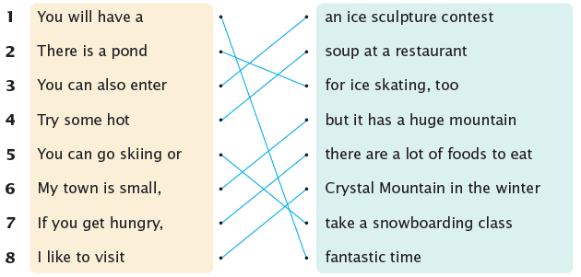

1. You will have a fantastic time!
2. There is a pond for ice skating, too.
3. You can also enter an ice sculpture contest.
4. Try some hot soup at a restaurant.
5. You can go skiing or take a snowboarding class.
6. My town is small, but it has a huge mountain.
7. If you get hungry, there are a lot of foods to eat.
8. I like to visit Crystal Mountain in the winter.
Unit 8 My Favorite Movie

A
2. I love watching movies.
3. I really like watching films.
4. I enjoy watching animation.

B
2. It is one of the coolest children’s movies.
3. It is one of the most interesting children’s movies.
4. It is one of the saddest children’s movies.

C
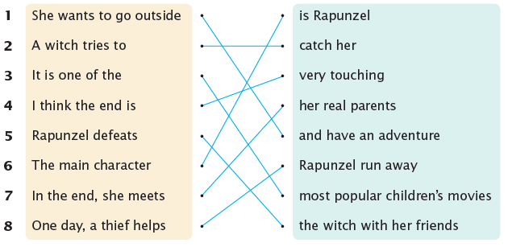

1. She wants to go outside and have an adventure.
2. A witch tries to catch her.
3. It is one of the most popular children’s movies.
4. I think the end is very touching.
5. Rapunzel defeats the witch with her friends.
6. The main character is Rapunzel.
7. In the end, she meets her real parents.
8. One day, a thief helps Rapunzel run away.

